REPORT
This manual provides a step-by-step guide for creating the account on the MetaMask and perform transaction.

Step 1: Create a MetaMask Account
To begin, you must install the extension and set up a secure wallet.
Installation: Navigate to the official MetaMask(MetaMask Crypto Wallet. Buy and Sell Bitcoin, Ethereum, Solana) website and select Browser Extension for your preferred browser (e.g., Chrome, Firefox, or Brave).
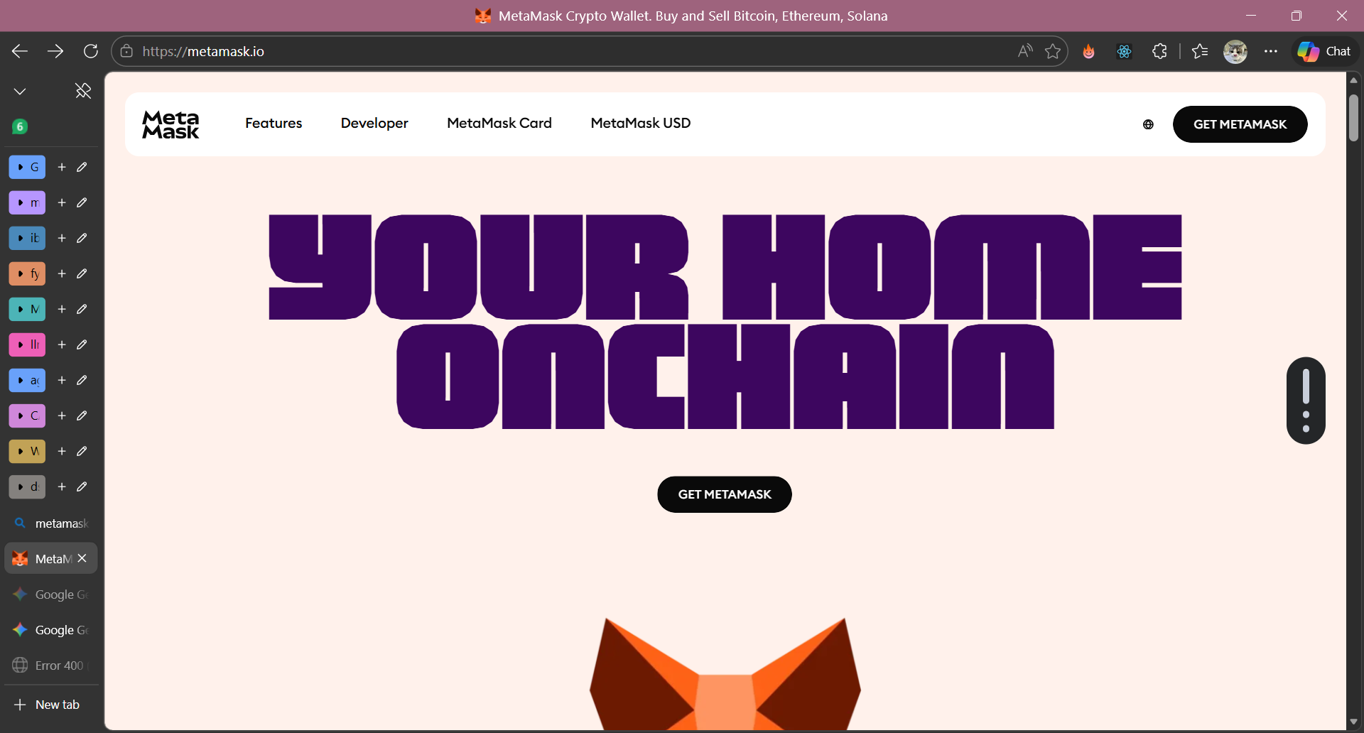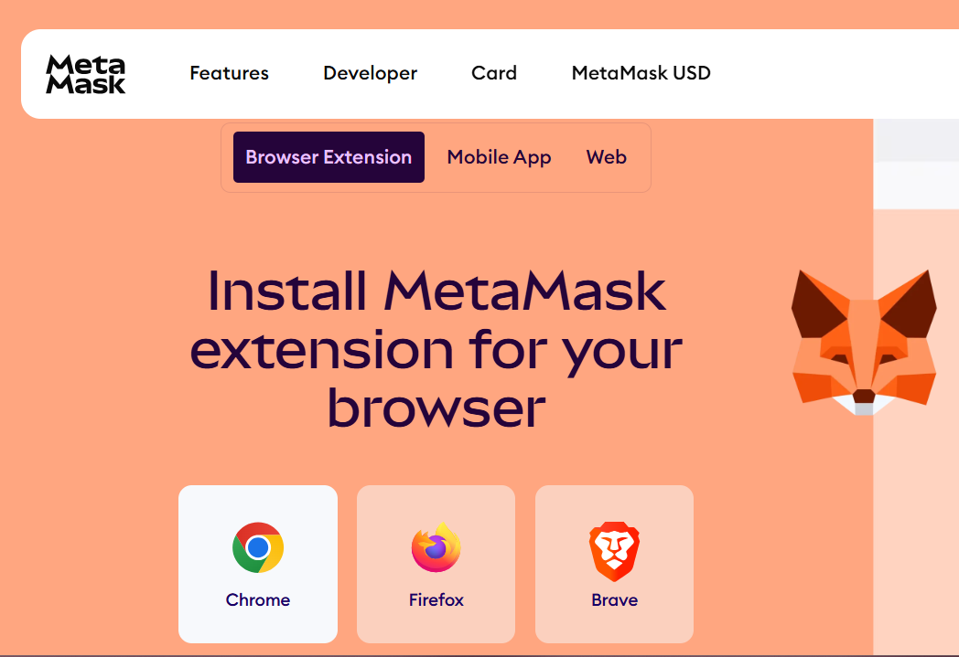
· Initial Setup: In the Chrome Web Store, click Add to Chrome to install the extension.
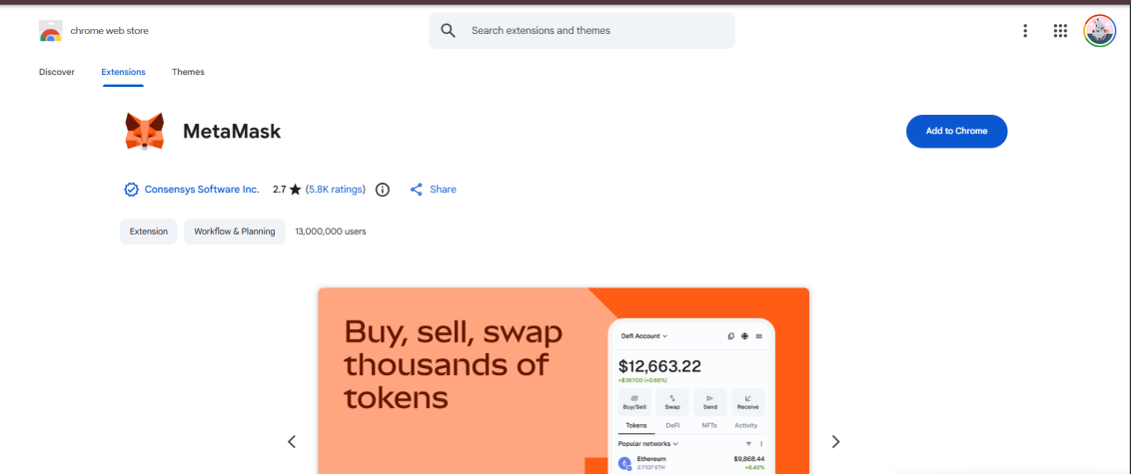
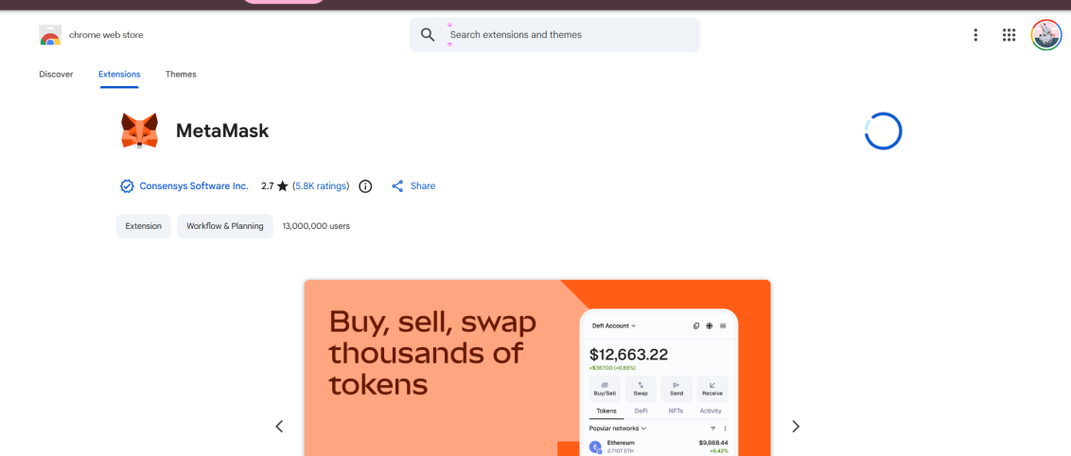
· Wallet Creation: Upon opening the extension, select Create a new wallet. You can choose to "Continue with Google" or set it manually
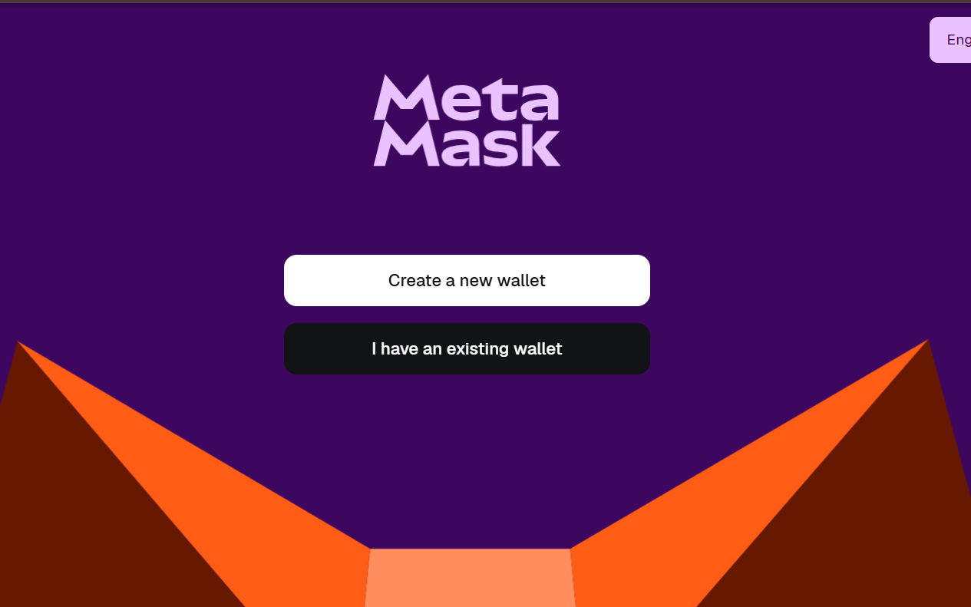
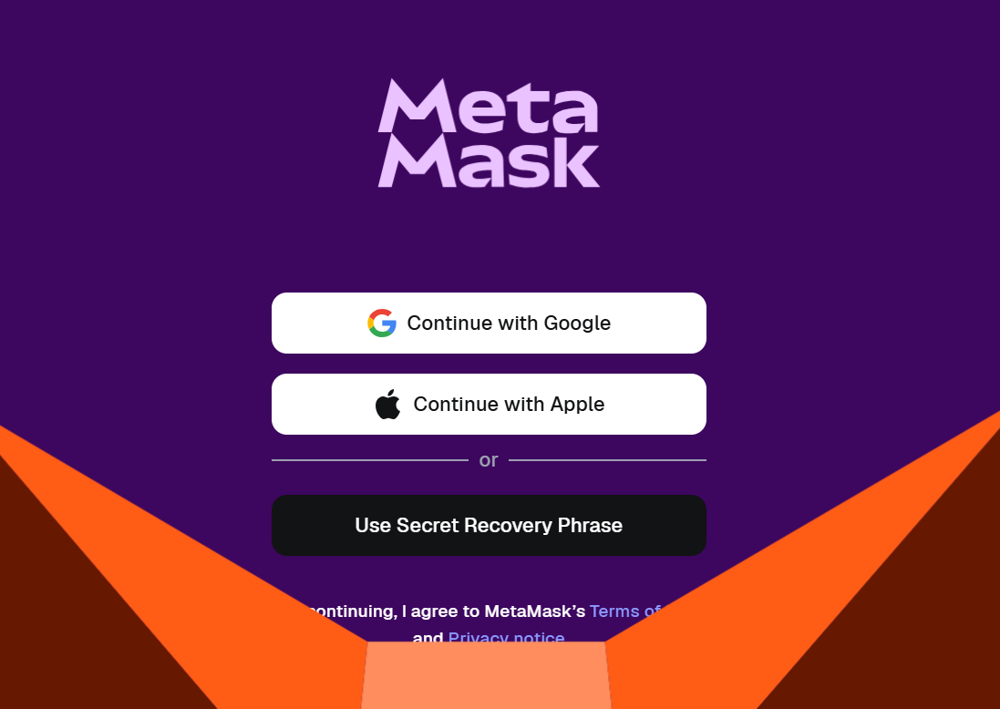
Security: Create a strong password (at least 8 characters) and check the acknowledgment box. Save your Secret Recovery Phrase in a secure location. Never share this with anyone.
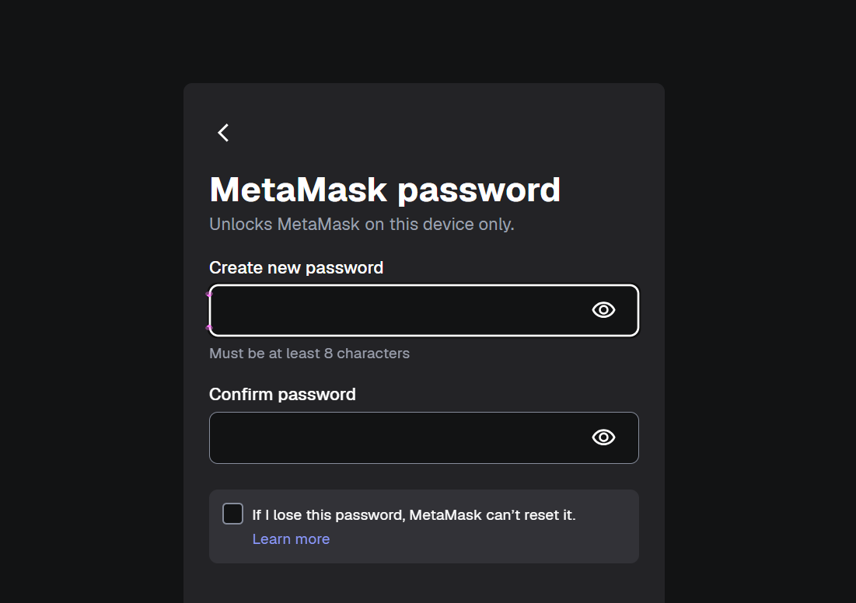
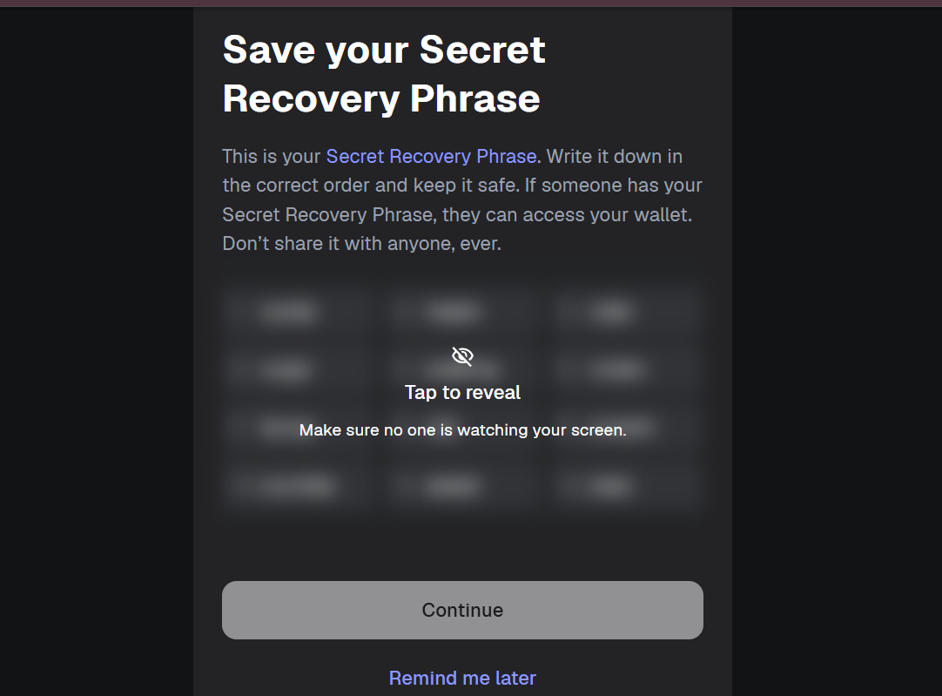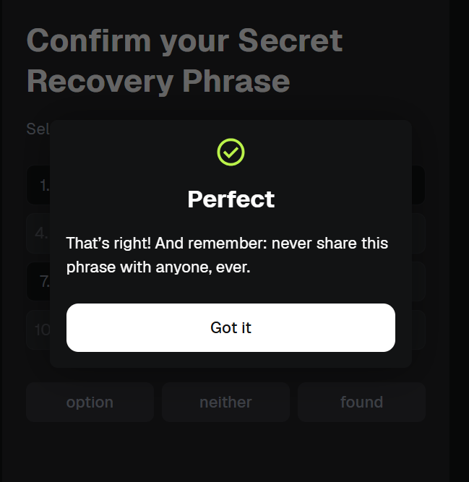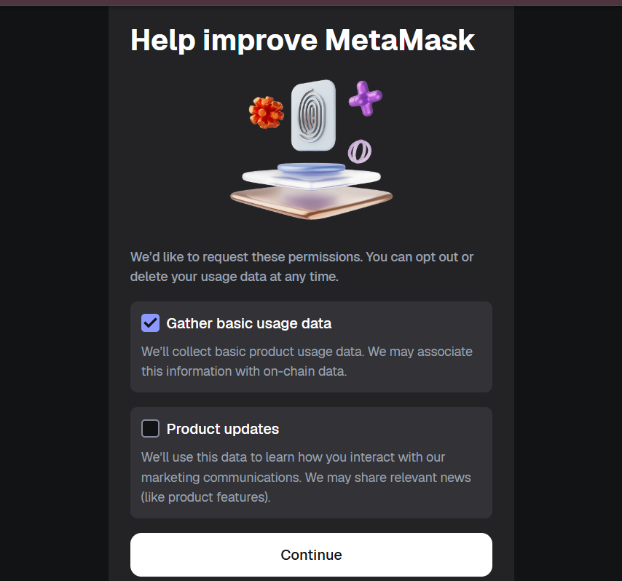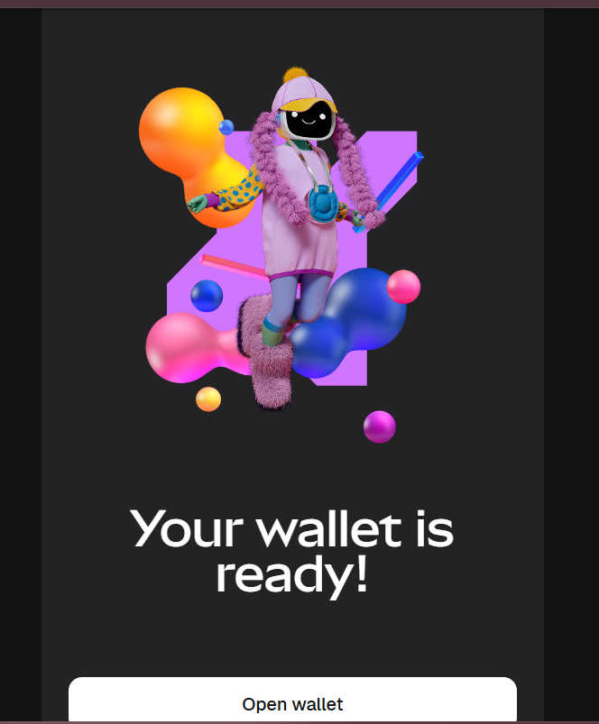

Step 2: Configure Sepolia Testnet
By default, MetaMask shows main networks. You must enable testnets to interact withSepolia.
· Access Settings: Click the three dots (menu) in the top-right corner of the MetaMask interface and select settings
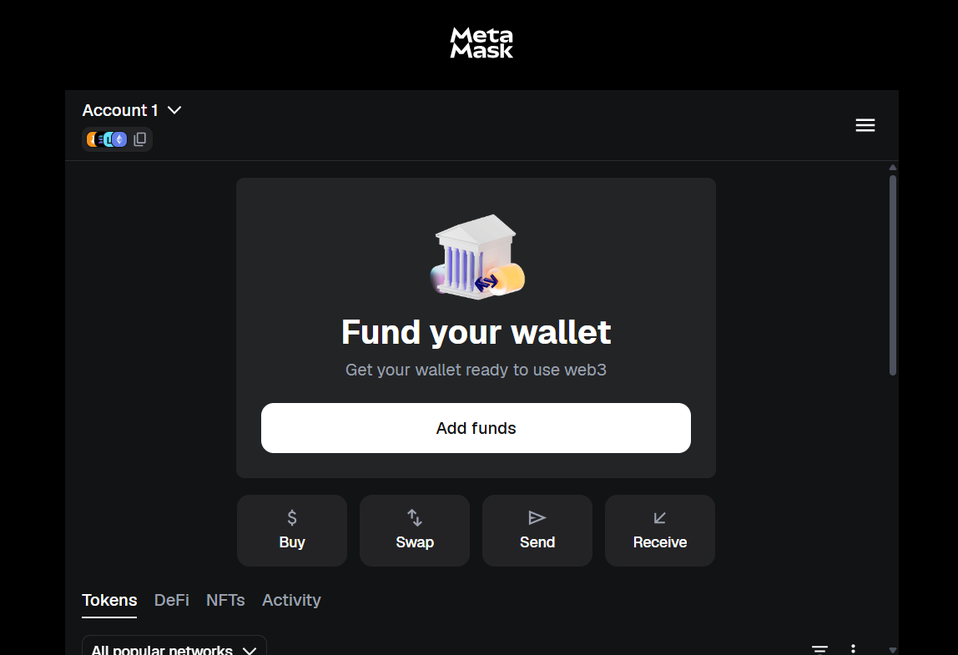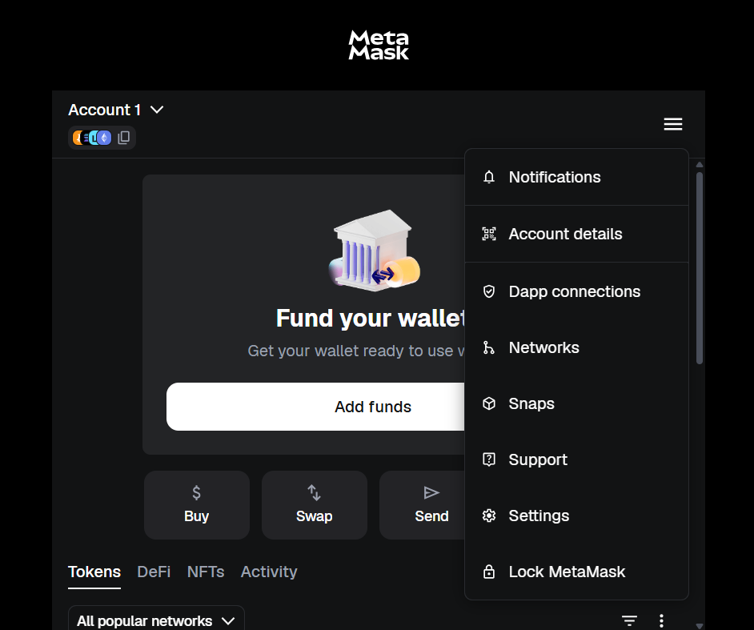
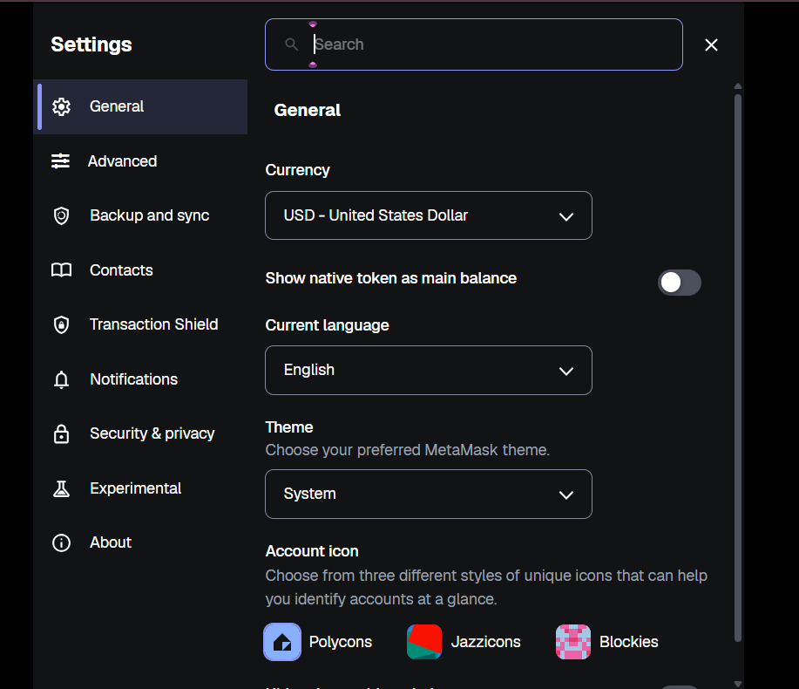
Enable Test Networks: Go to the Advanced tab. Scroll down to find the Show test networks toggle and switch it on
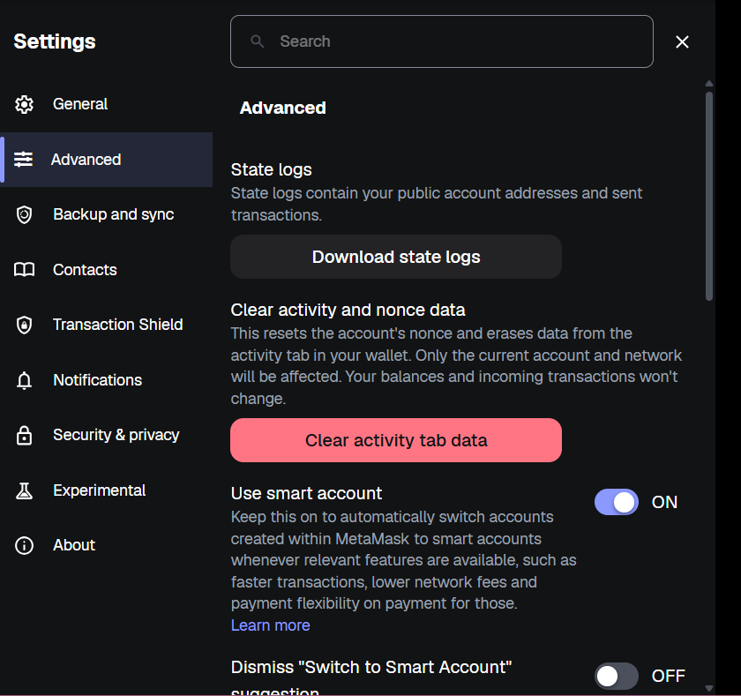
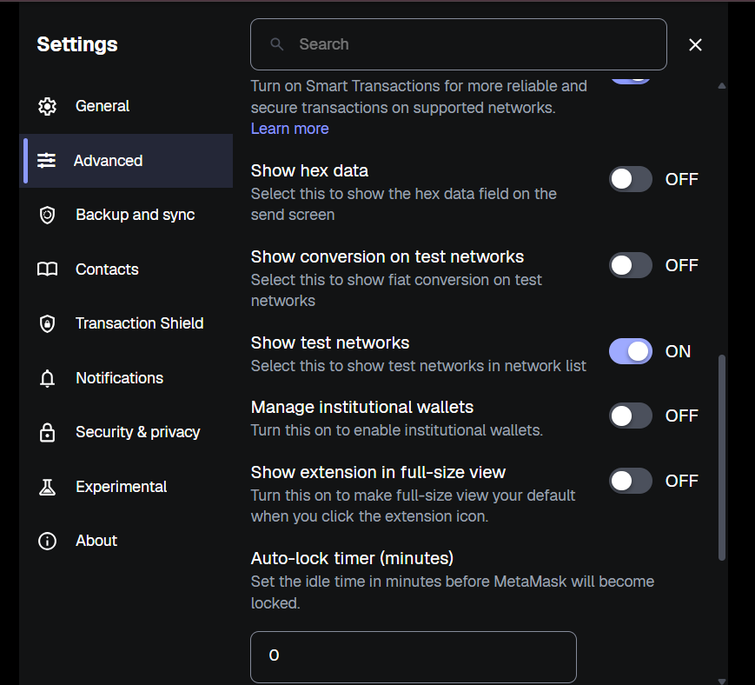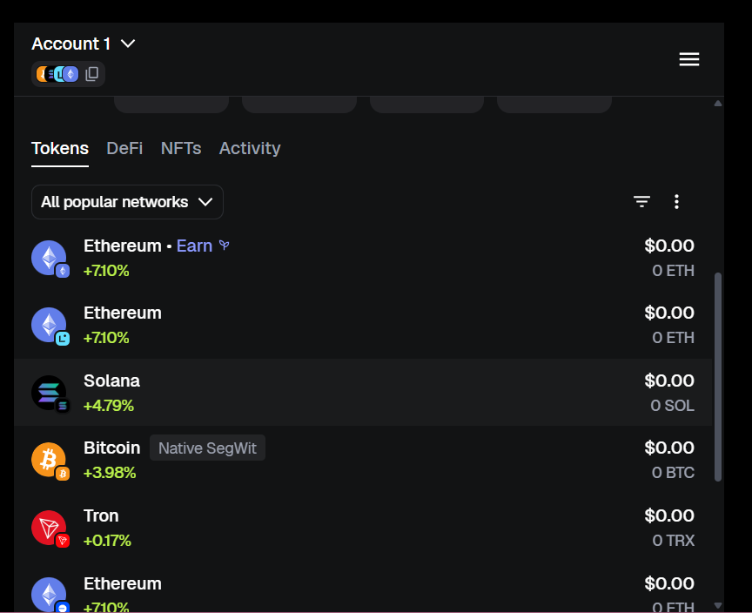
Select Network: Close Settings, click the network selector in the top-left (e.g., Ethereum Mainne and choose Sepolia from the list).
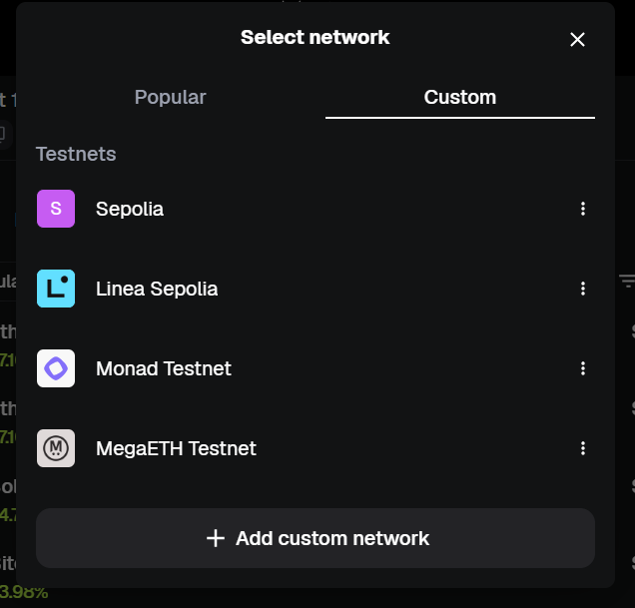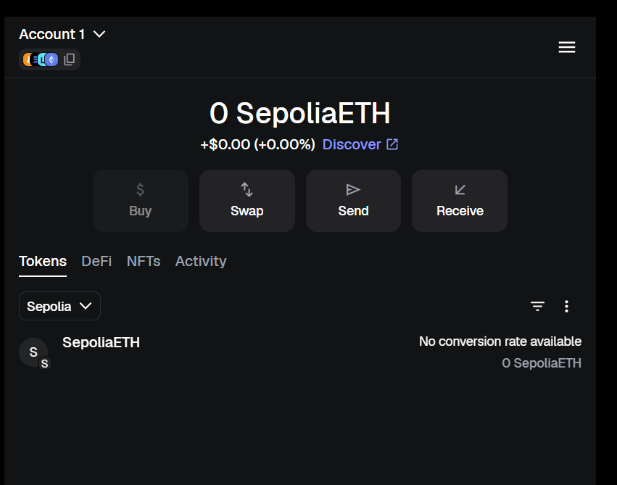
Funding: Use a faucet, such as the Google Cloud Web3 Ethereum Sepolia Faucet, to request test ETH. Paste your wallet address and click Get 0.05 Sepolia ETH.
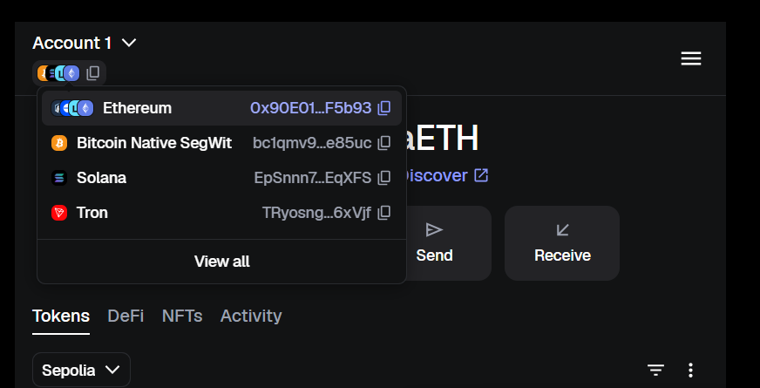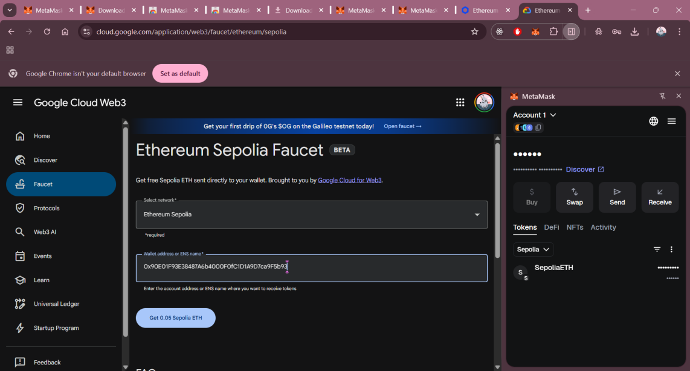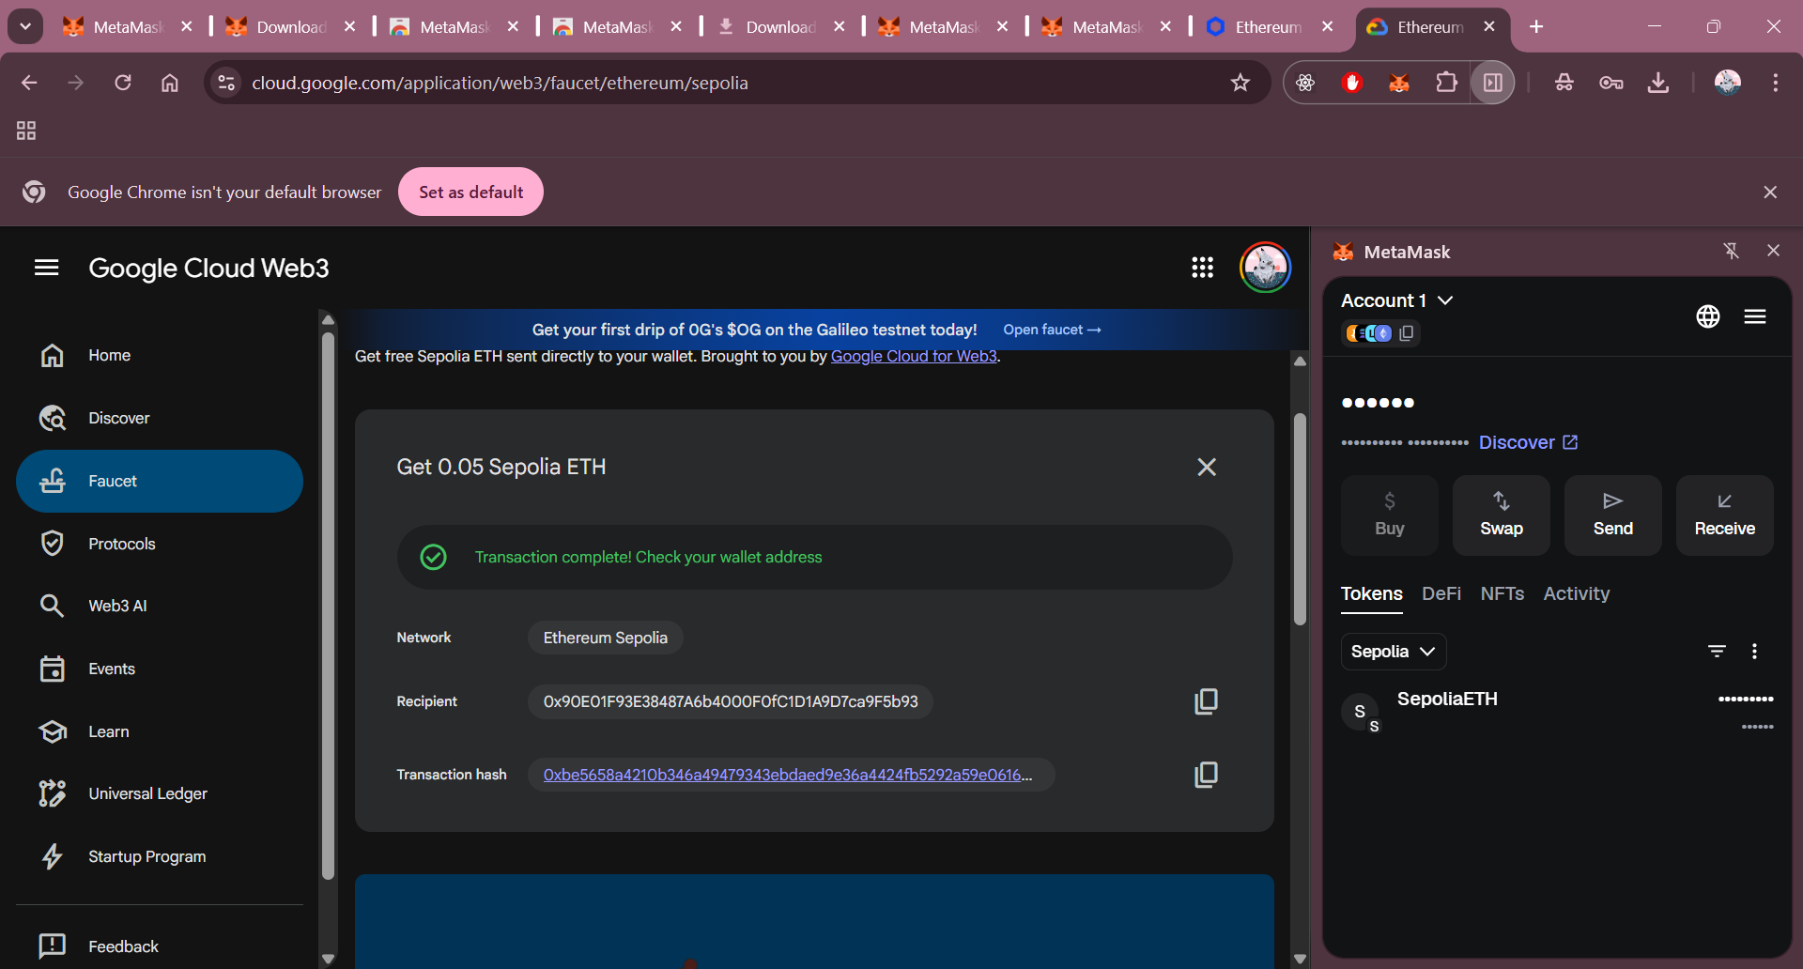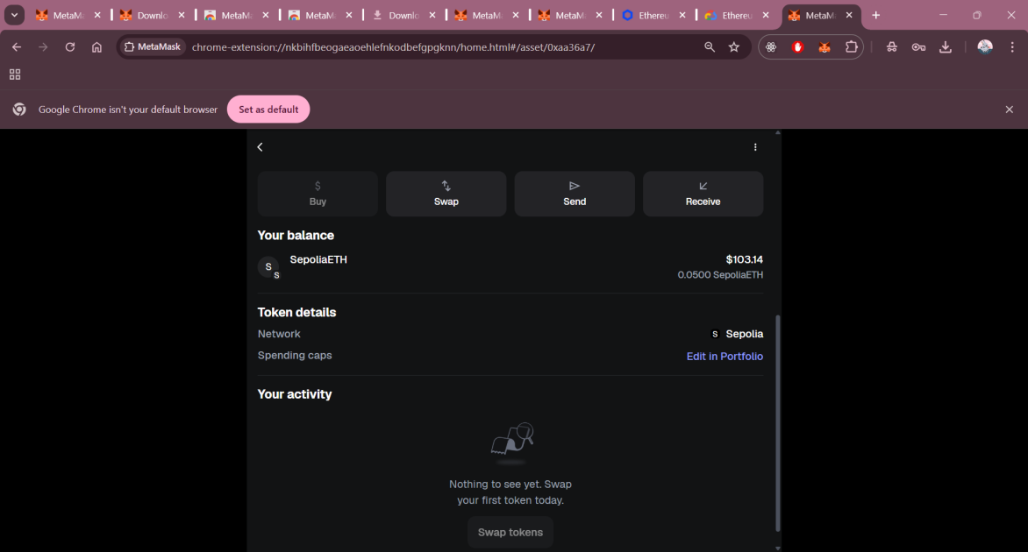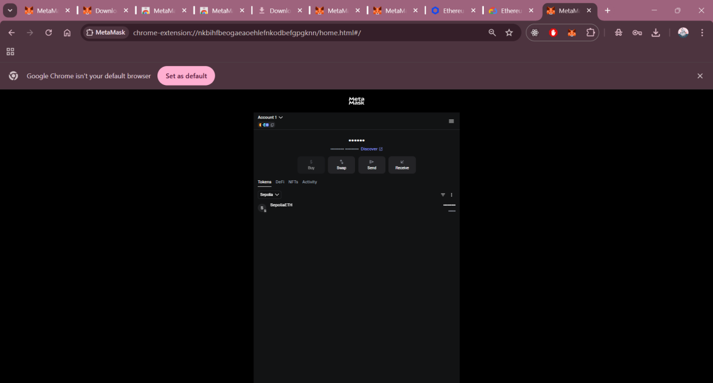

Step 3: Create Second Account and Perform Transaction
To test internal transfers, you need a secondary account within the same wallet.
Create Account-2: Click the account selector at the top and select Add account. Name it "Account 2".
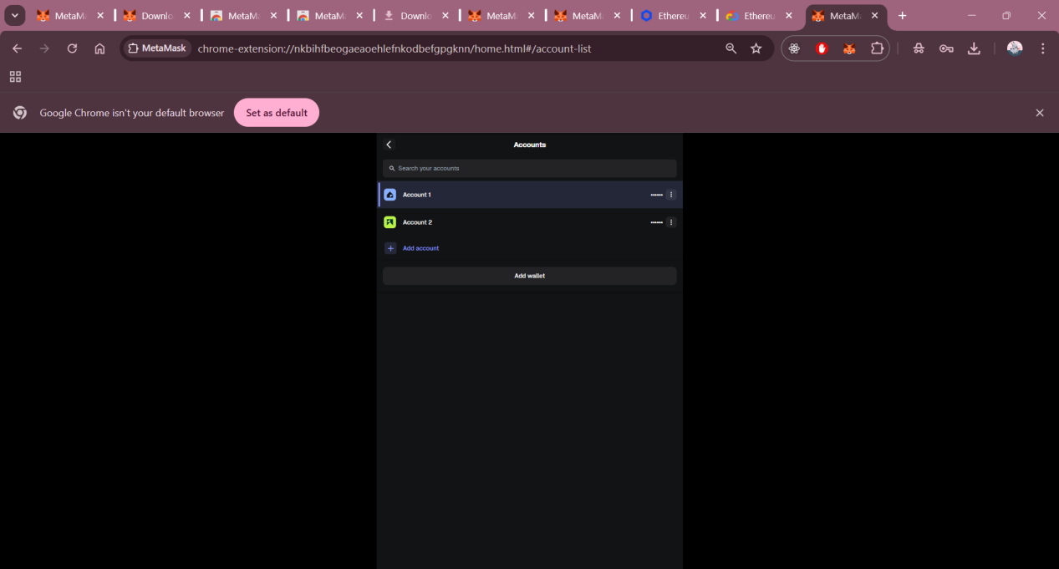
Initiate Transfer: Switch back to Account 1. Click the Send button.
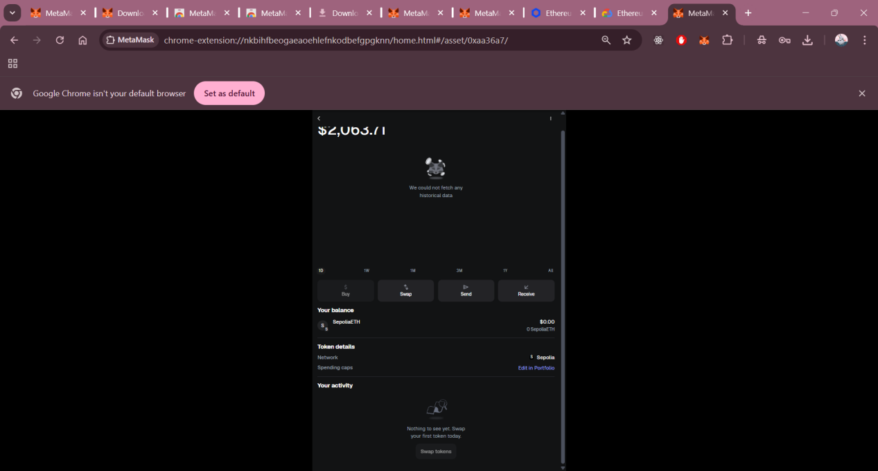
Select Recipient: In the search bar, select Account 2 from your own accounts list.
Amount: Enter the amount to transfer (e.g., 0.006979 Sepolia ETH).
Confirm: Review the network fees and click Confirm. The transaction will appear as "Pending" in the Activity tab until it is "Confirmed".
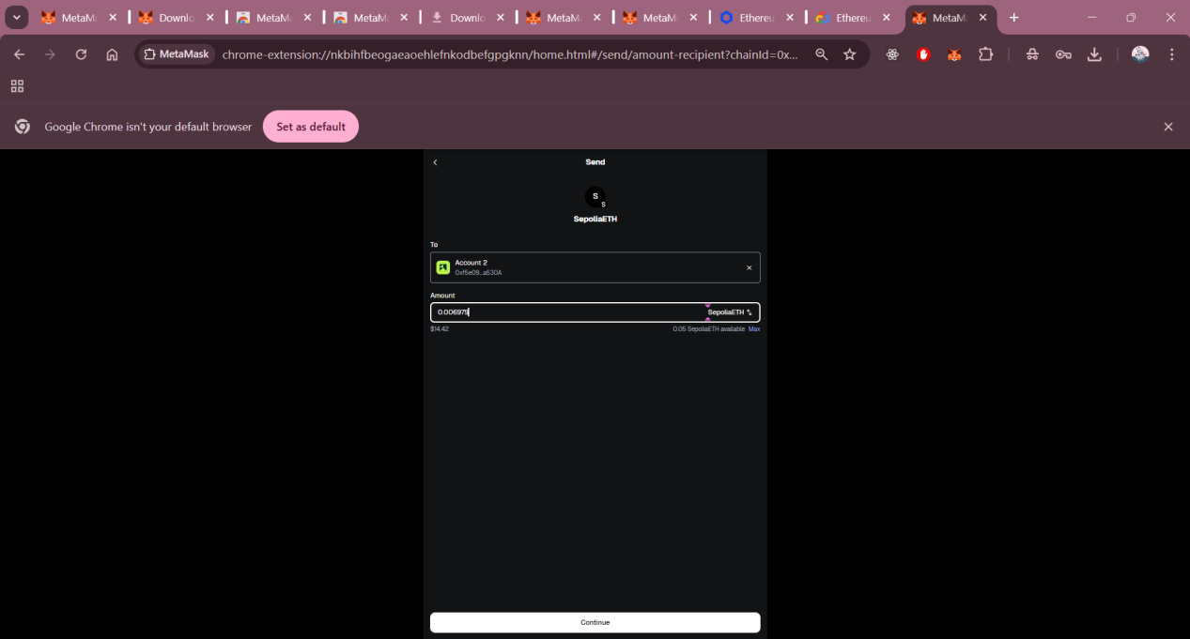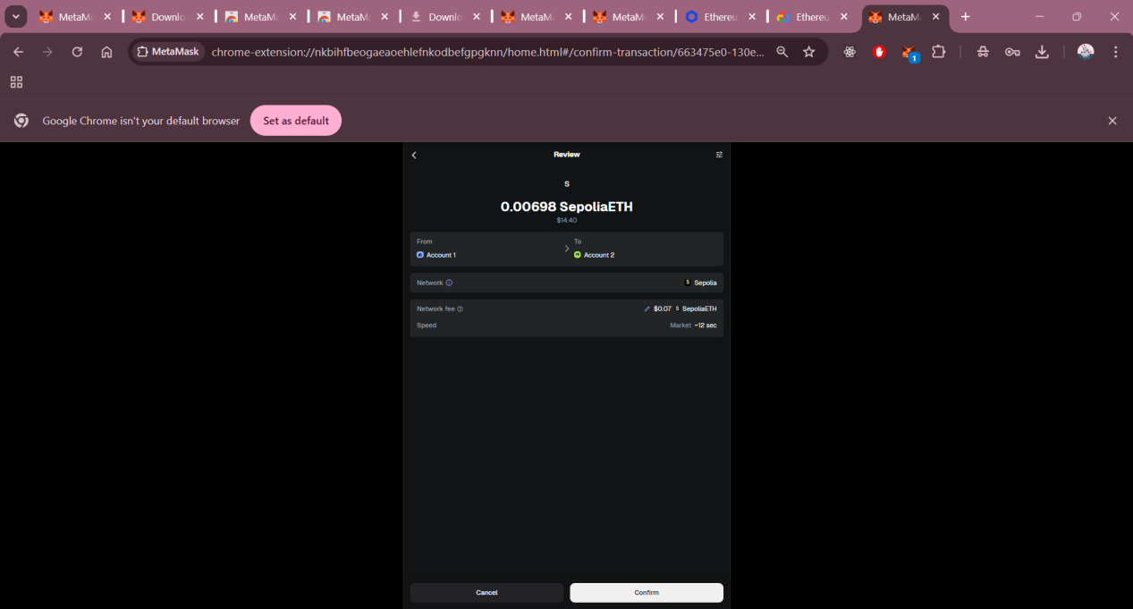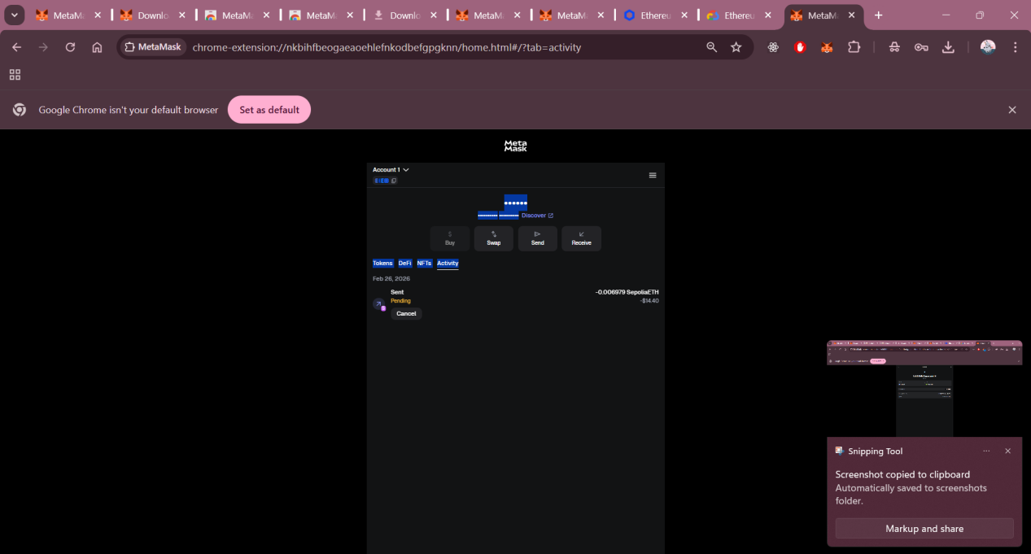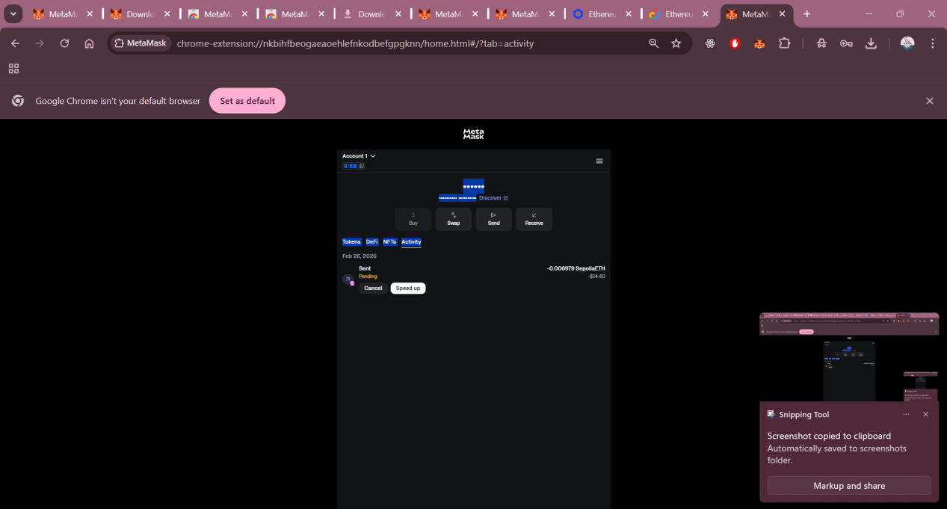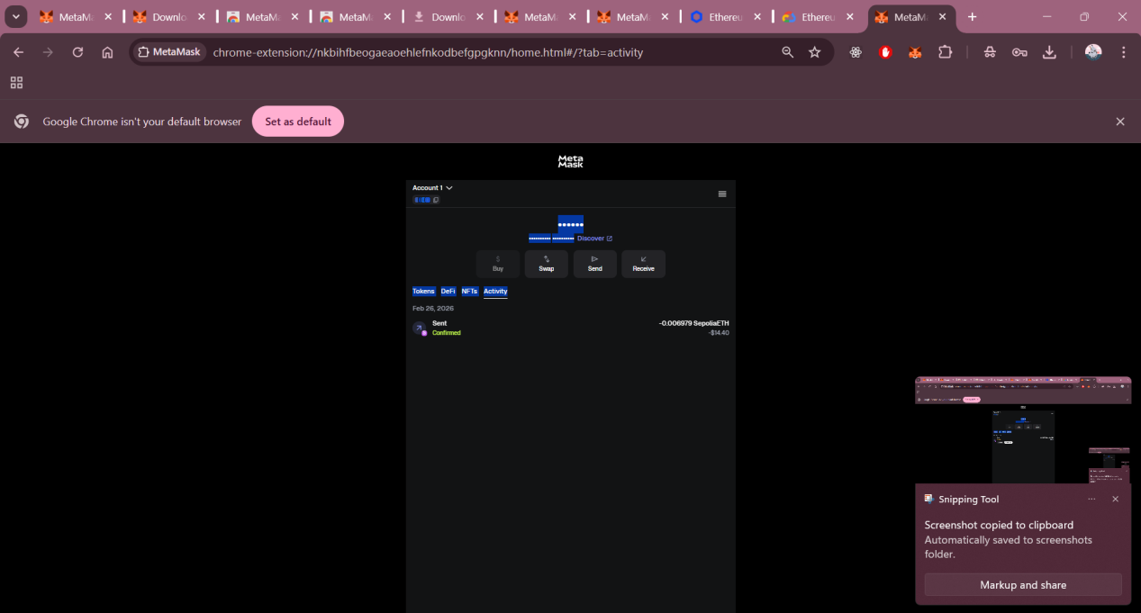

Step 4: Check Transaction on Block Explorer
Verify the transaction on the public ledger.
View Details: In the Activity tab, click on the confirmed transaction and select View on block explorer.
Verification: This will open Sepolia Etherscan, showing the unique Transaction Hash, the status as Success, and the confirmed transfer of funds from Account 1 to Account 2.
